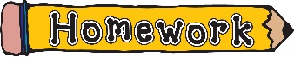

**Homework:**

Homework is set every Friday and needs to be handed in by the following Monday.

Year 1

Term 2.1

**

We will be learning:

* Why people in the past had a desire to fly
* To understand how people from the past travelled
* The invention of hot air balloons
* To say how and why aeroplanes were discovered
* How aeroplanes were developed

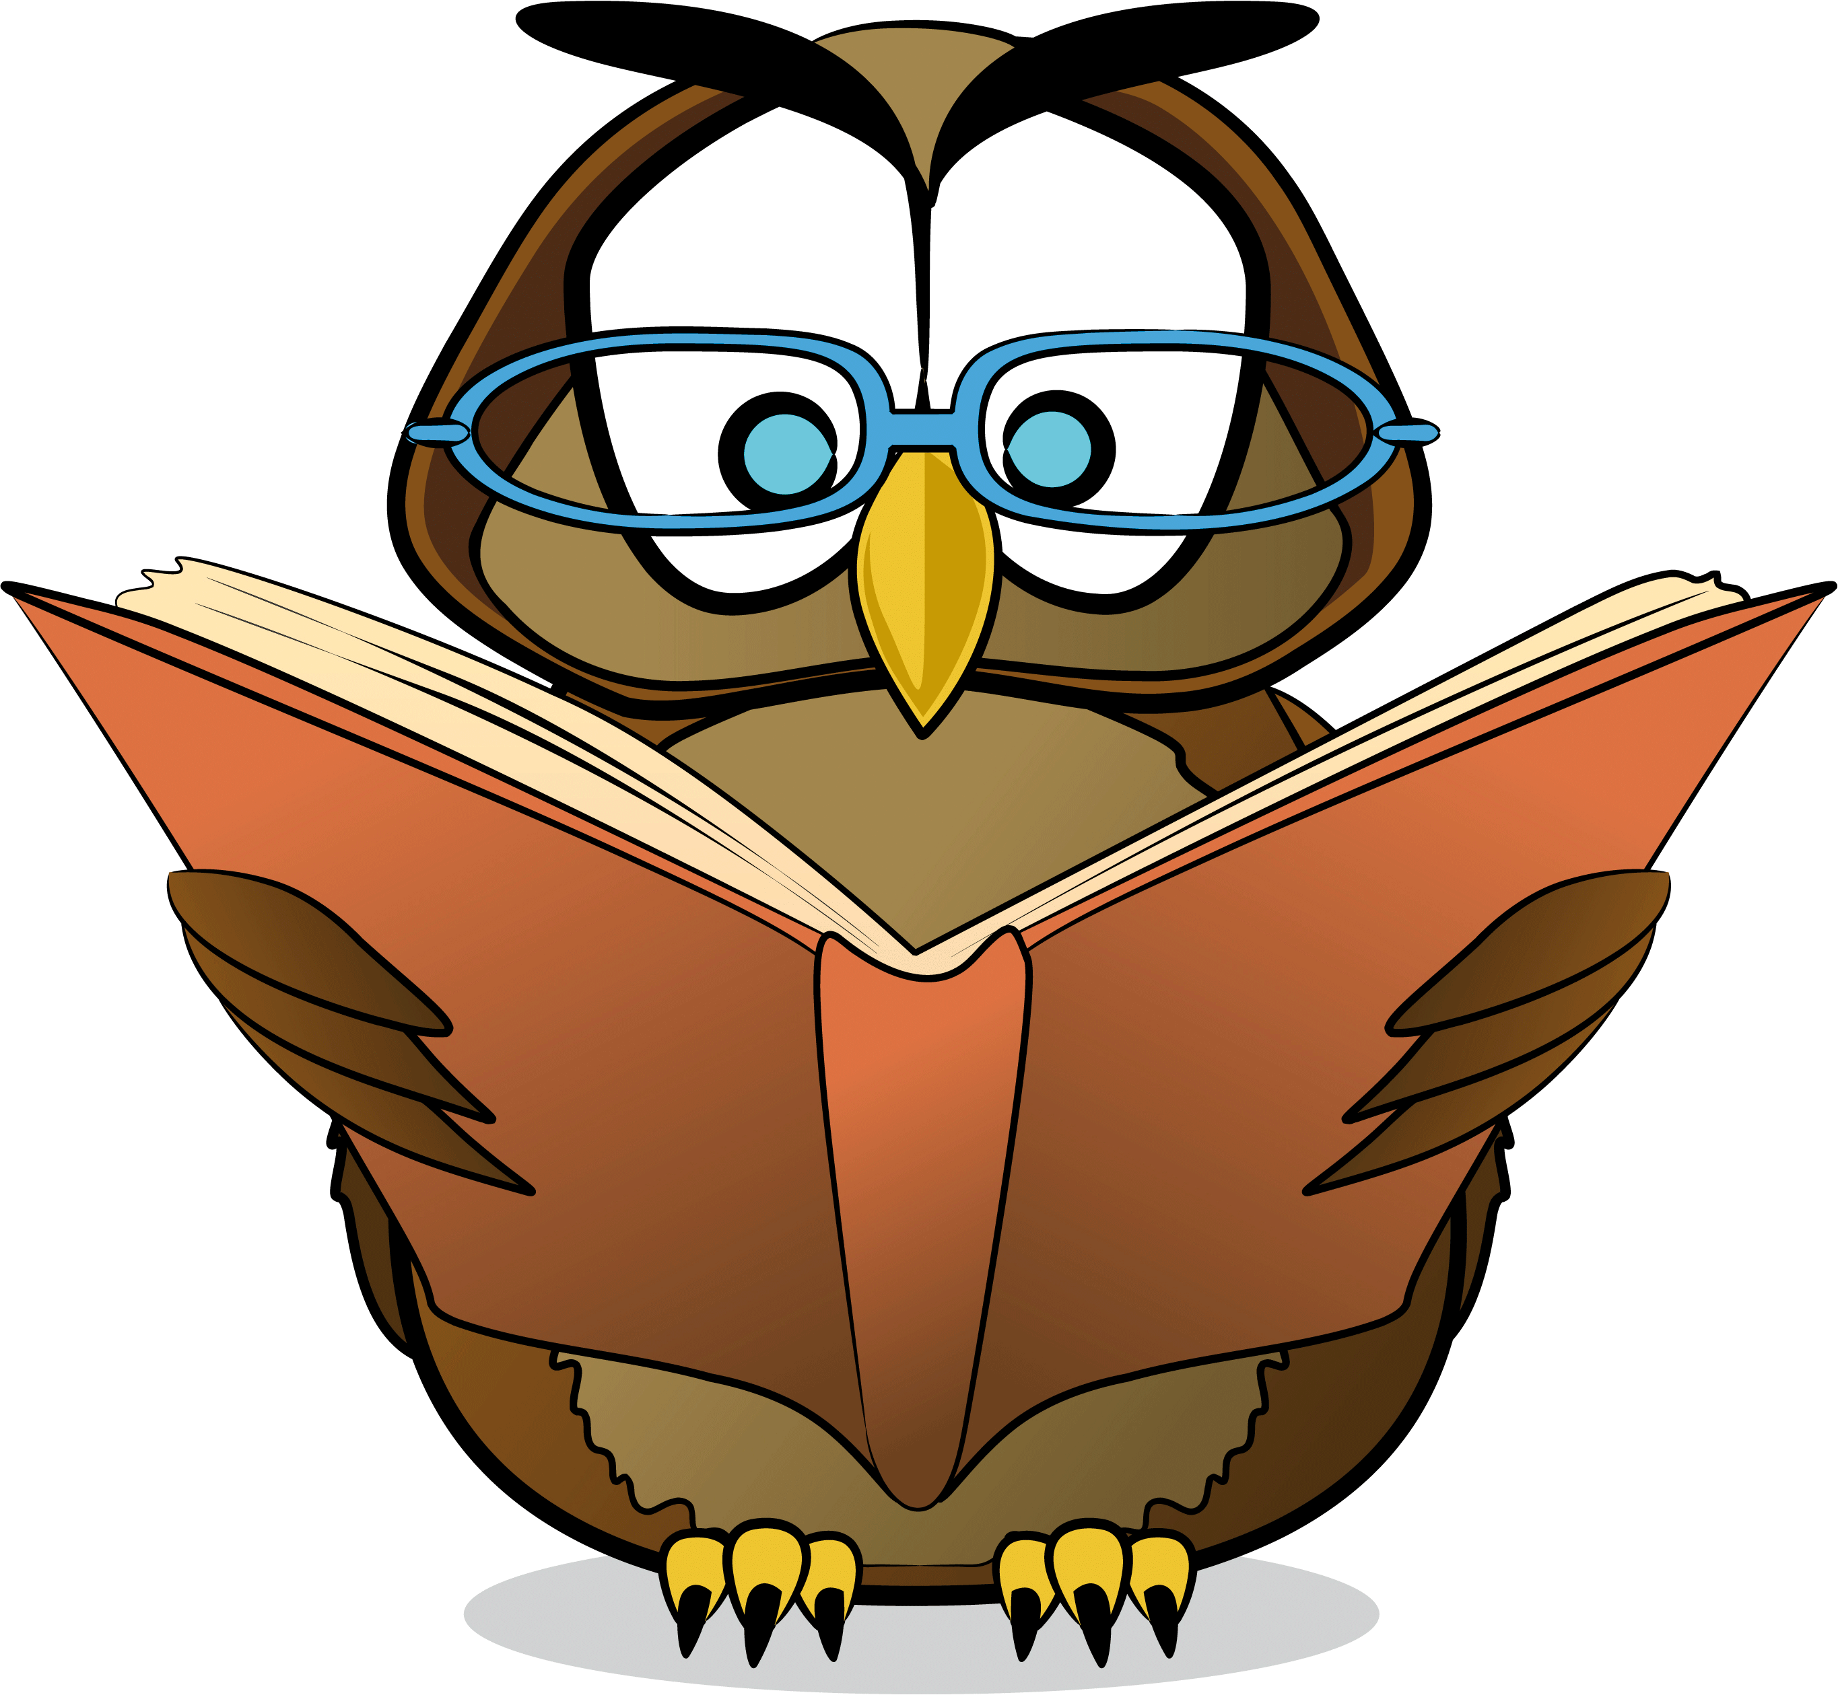

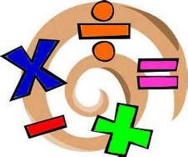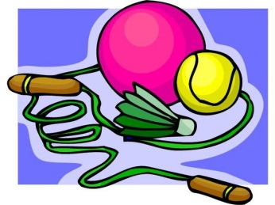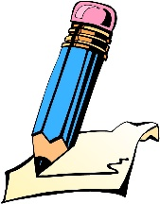

**Numeracy:**

We will be learning:

* Number place value within 50
* Identify one more and one less within 50
* Use language more than, less than and equal to
* Addition and subtraction
* Measurement

**Reading:**

Your child gets a Guided Reading book and a class library book once a week. They need to bring both books in their school book bags or plastic book bags to school in order to take a new book home. Please encourage your child to read daily for 10 minutes with the support of an adult.

**PE:**

We have PE sessions every Tuesday, so it is vital that your child comes into school wearing their PE kit. Your child’s P.E kit should contain:

• P.E.- a plain white t-shirt

(not football shirts or any other sporting T-shirt)

• Black shorts/jogging bottoms (close fitting leggings may be worn by girls).

**Literacy:**

At the beginning of this term, we will be focusing on traditional stories. Children will be exploring the features of fiction texts and will be identifying the beginning, middle and end of traditional stories. Subsequently, they will be using key features to write their own traditional stories. At home, please encourage your child to write sentences/stories using their phonic knowledge, capital letters, finger spaces, adjectives, and full stops.