Writing  Narrative and Non-chronological reports | 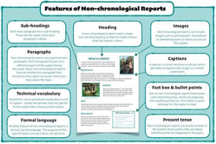 |  | Reading  Fiction texts |  | 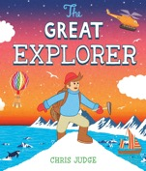 | Numeracy  Times tables, Shape and Statistics |  | 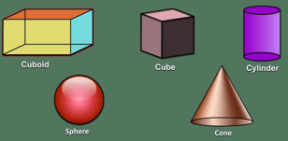
We are learning to…  - Know what the purpose of non-chronological reports are  - Identify the organisational and language features of Non-chronological reports and Narratives  - Write a non-chronological report and a narrative  We are focusing on the following skills:  - Grouping sentences to a common idea  - Extending sentences using but  - Select the most effects verb, adjective and noun |  |  | We are learning to…  - Use our phonetic knowledge to read with fluency and decode unfamiliar words  - Answer retrieval questions: Who, what, where, when and why  - To summarise information from a page  Please encourage your child to read with you every day.  This term our focus text is The Great Explorer Sands written by Chris Judge |  |  | We are learning…  - To recall multiplication and division facts for the 2, 5 and 10 times tables  - To create and read simple pictograms  - To create simple tables, tally charts and block diagrams and answer questions about the data they present  - To name a range of 2D and 3D Shapes
Science |  | RE/PSHE |  | LFL |  |  | PE
This half term, we will be focusing on Biology.  We will be learning about…  - A variety of plants and the habitats they belong to.  - Omnivore, herbivore, carnivores  - Food chains |  | This half term, we will be learning about…  - How jobs help people earn money to pay for things they need and want  - About a range of different jobs, including those done by people we know or work in our community  - How people have different strengths that enable them to do different jobs.  - How people use the internet and digital devices in their jobs and everyday life. |  | This half term, we will be focusing on History and Art.  In History, we will be learning about…  - What expeditions are and why people went on them  - Identify what primary and secondary sources are in History and why they are used  In Art, we will be learning about…  - The artist Bob Ross and landscape art  - How to create tints and tones  In Computing we will be  - Learning how to use and program a Sphero |  |  | In PE this term, we will be focusing on Fitness and Dance.  PE is on Wednesdays  Your child must wear the appropriate PE kit.  - Black shorts or tracksuits. Black leggings may be worn by girls.  - Trainers or pumps  - A plain white t-shirt

