Writing  Stories from a different culture  Focus Text | 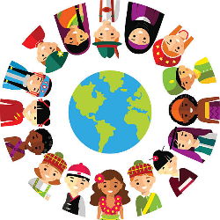 |  | Reading |  | 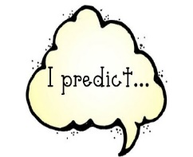 | Numeracy |  | 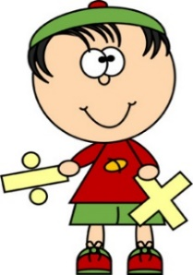
We are learning to…  - Use a range of punctuation  - Generate and use descriptive language  - Continue to use connectives and conjunctions to join ideas and extend sentences |  |  | We are learning to…  - Revise and recap retrieval and inference  - Summarising a text  - Predicting details  - Answering test style questions  Please read with your child every day for at least 10 minutes. Please leave a comment in reading journals. |  |  | We are learning to…  - Fractions  - Measurement  - Money  - Multiplication and division
Science |  | RE/PSHE |  | Foundation Subjects |  |  | PE
This half term we will be focusing on Light.  We will be learning about…  - Exploring light and what is  - Exploring darkness and what it is  - How light is reflected from surfaces  - How light travels from a source  - The dangers of looking at the sun |  | This half term we will be learning about…  - ‘Being fair and just’  - What does it mean to be fair and just?  - Exploring this concept within different faiths |  | This half term for Humanities, we will be focusing on History.  For Art, we will be focusing on Sculpture.  We will be learning about…  - The Shang Dynasty  - Creating sculptures using clay |  |  | In PE this term, we will be focussing on…  - Dance/OAA  PE is on Mondays.  Your child must wear the appropriate PE kit.  - Black shorts or tracksuits. Black leggings may be worn by girls.  - Trainers or pumps  - A school house t-shirt or plain white t-shirt

