Writing  Genre: Historical fiction, diary entries, poetry |  |  | Reading  Class Text: How to Train Your Dragon by Cressida Cowell | 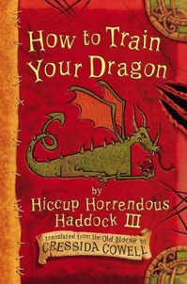 | Numeracy  Multiplication, division and area |  | 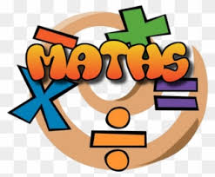
We will be linking our writing to the Vikings and to our class text: How to Train Your Dragon.  We are learning…  - To make specific language choices for effect  - To use historical vocabulary accurately  - To write complex sentences, including accurate punctuation  - To use paragraphs for a range of purposes |  |  | We are learning…  - To make suitable predictions about events  - To justify predictions using evidence stated and implied within the text  - To understand how the author has used key words/ phrases to create an effect |  | We are learning to…  - Measure and calculate the area of rectilinear shapes  - Recall and use multiplication facts up to 12 x 12  - Solve problems involving multiplying and adding  - Recognise and show, using diagrams, families of common equivalent fractions.  - Count up and down in hundredths and tenths  - Add and subtract fractions with the same denominator.
Science |  | RE/PSHE |  | History |  | PE
This half term we will be focusing on Physics.  We will be learning about…  Electricity  Computing  Everyone Can Create  - Using iBooks to sketch |  | This half term we will be learning about…  - Being modest and listening to others  - Cultivating Inclusion, identity and Belonging  - How to identify and manage our feelings |  | Topics: Vikings  - How the Viking era began  - Where the Vikings came from.  - Were the Vikings always violent.  - We will also be looking at how the Vikings were represented and if the information was biased. |  | In PE this half-term we will be focussing on…  Dance and OAA  PE is on Thursdays.  Your child must wear the appropriate PE kit. This involves….  - Shorts or tracksuits. Close fitting leggings may be worn by girls.  - Trainers or pumps  - A white t-shirt or a house t-shirt
Please ensure your child is on time everyday otherwise they are missing out on their crucial learning time.

