Term 3.1 This half term in Year 5 we are learning about…
Writing and Grammar | Genre: Newspapers and Explanation texts  We will be learning:  - How to structure different genres of writing  - How to use the language used in both types of genres of writing  - How to use suitable vocabulary for the Audience of our writing  - How to include a range of punctuation for a purpose.
Reading and Spelling  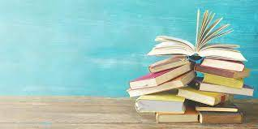 | We will be…  - Summarising the main ideas from more than one paragraph.  - Identifying how language, structure and presentation contribute to meaning.  - Learning how to make sensible predictions from details that have been stated and implied in the text.  - Continuing to develop our retrieval and inference skills.
Numeracy  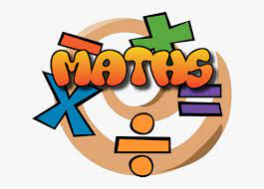 | Focus:  We are learning…  - To write percentages as fractions and decimals  - Understand and use approximate equivalences  - Measure and calculate the perimeter of rectilinear shapes  - Calculate and compare the area of rectilinear shapes  - Estimate the area of irregular shapes
Science | Topic:  We will be learning about …  - The differences in the life cycles of a mammal, an amphibian, an insect and a bird  - The life process of reproduction in some plants and animals  - Seed dispersal, pollination and germination in plants.
History and Art  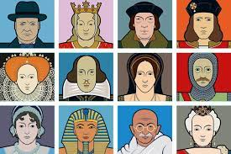 | History:  Learning through: History  Our new enquiry question: Can you ever be too small to make a difference?  Key historical figures who have made a significant difference on our lives today.  Art: Celebration of the Queen’s jubilee using inspiration from Pablo Picasso.  Music: Motown songs from the 1960’s.
Physical Education | Please remember to wear your PE kit on a Monday.  Your child will be developing their physical skills through:  - Cricket and Athletics  Your child must wear the appropriate PE kit.  - Black shorts or tracksuits. Black leggings may be worn by girls.  - Black Trainers or pumps  - A school house t-shirt or plain white t-shirt
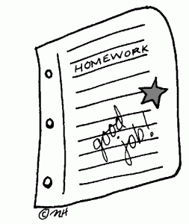  Homework | This will be handed out every Friday. This is set by your child’s teacher to consolidate and extend their learning.  Your child will also be sent home a reading book on a Friday and this will need to returned on Monday.  We would encourage children to spend at least 15-20 minutes each day reading.

