Writing  Narrative & Explanation text | 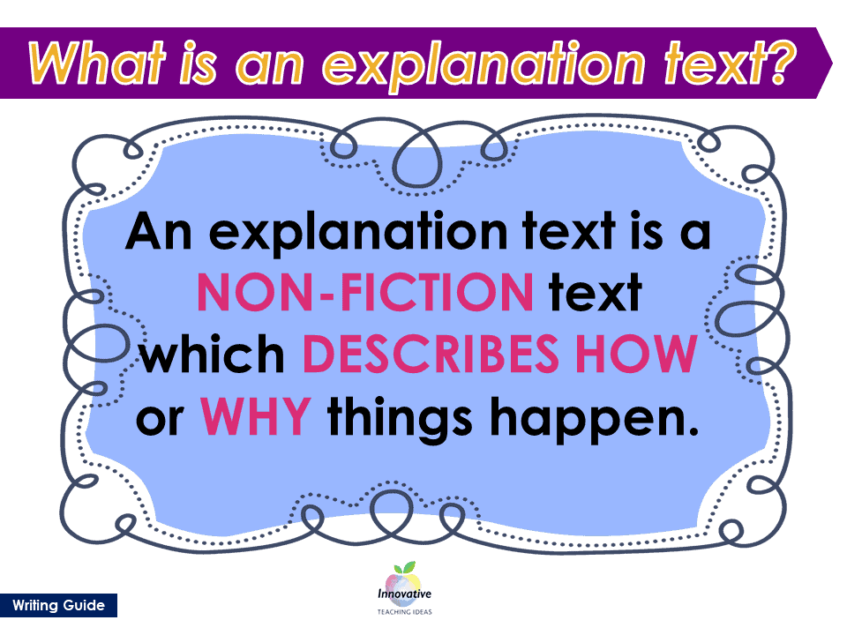 |  | Reading  Fiction texts |  |  | Numeracy
We are learning to…  - Know what the purpose of an explanation text is.  - Identify different types of explanation texts.  - Identify the organisational and language features of explanation texts.  - Write a narrative & an explanation text.  We are focusing on the following skills:  - Grouping sentences to a common idea to write a paragraph to demarcate the beginning, middle and end of the story.  - Extending sentences using a wider range of conjunctions: but and that.  - Using irregular past tense verbs and spelling them correctly. |  |  | We are learning to…  - Use our phonetic knowledge to read with fluency and decode unfamiliar words.  - Answer retrieval questions: Who, what, where, when and why.  - To begin to answer inference questions  - To answer a range of different style retrieval questions; Tick box, true or false and find and copy questions.  Please encourage your child to read with you every day.  This term our focus text is The Lighthouse Keeper’s Lunch by Ronda and David Armitage |  |  | We are learning to.....  - Solve a variety of addition Maths problems, including finding all possibilities, odd one out, true or false.  - Solve problem involving money including finding change.  - Children will learn how to use positional and directional language.  - To read time on an analogue clock, to the hour, half past the hour and quarter past the hour.  - We will finish the term with multiplication and division facts.
Science |  | RE/PSHE |  | LFL |  |  | PE
This half term, we will be focusing on Biology.  We will be answering the question:  What do animals and humans need to survive?  We will learn about:  - What basic elements animals and humans need to survive.  - Identify different parts of the human life cycle.  - Identify offspring of different animals. |  | This half term, we will be learning about…  - What can help us grow and stay healthy.  - What it is like to be quiet in a place of worship.  - Understanding that perfection is not a static concept. |  | This half term, we will be focusing on History and Art  In History, we will be answering the question: Why is Aston Hall so significant to us today?  We will learn about  - Who built Aston Hall  - The changes to ownership and purpose to this building  - Why Aston Hall became damaged  In Art, we will be learning about the great work of Georges Suerat – Pointillism  In Computing we will be… researchers!  - The children research a topic – safely, effectively and efficiently – using a structured approach (mind mapping). They share their findings with others through a short multimedia presentation. |  |  | In PE this term, we will be focusing on athletics and invasion.  PE is on Wednesdays  Your child must wear the appropriate PE kit.  - Black shorts or tracksuits. Black leggings may be worn by girls.  - Trainers or pumps  - A plain white t-shirt

