Writing  Biography and Diary entry  Focus Text  Escape from Pompeii  Roman diary – The journey of Iliona |  |  | Reading |  |  | Numeracy |  | 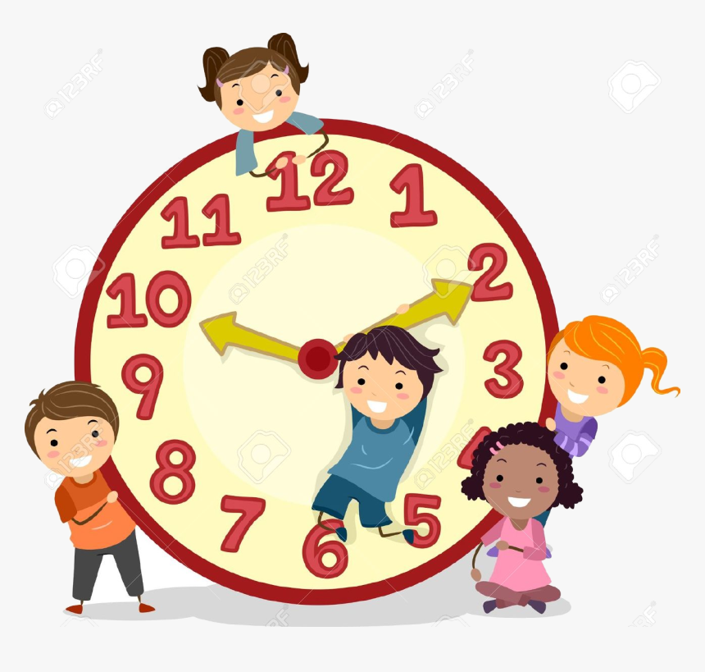
We are learning to…  - Use fronted adverbials  - Generate and use descriptive language  - Use subordinating conjunctions  - Use the relevant organisational and language features |  |  | We are learning to…  - Revise and recap retrieval and inference  - Predicting details  - Answering test style questions  Please read with your child every day for at least 10 minutes. Please leave a comment in reading journals. |  |  | We are learning to…  - Fractions - Comparing, ordering fractions and finding equivalent fractions  - Time – Telling the time (quarter past, quarter to, five-minute intervals) and problem solving related to time and duration
Science |  | RE/PSHE |  | Foundation Subjects |  |  | PE
This half term we will be moving on to Biology and focusing on animals and humans.  We will be learning …  - To identify that animals, including humans, need the right types and amount of nutrition  - To identify that humans and some other animals have skeletons and muscles for support, protection and movement. |  | This half term we will be learning about…  - Being open honest and truthful  - Unit: Health and Wellbeing:  Why should we eat well and look after our teeth? |  | This half term for Humanities, we will be focusing on History.  For Art, we will be focusing on portrait artists.  We will be learning about…  - The Roman empire and the impact they had  - In Art, looking at creating a portrait of the Queen in the style of pop art. |  |  | In PE this term, we will be focussing on…  - Athletics  PE is on Mondays.  Your child must wear the appropriate PE kit.  - Black shorts or tracksuits. Black leggings may be worn by girls.  - Trainers or pumps  - A school house t-shirt or plain white t-shirt

