Writing  Genre:  Persuasive letters and historical fiction | 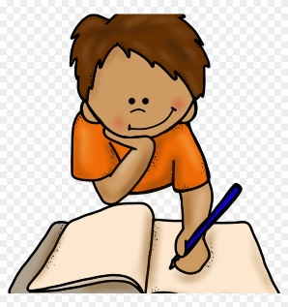 |  | Reading  Class Text:  Street Child | 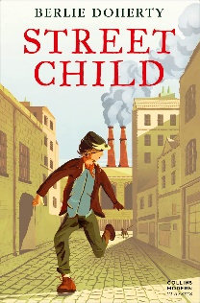 | Numeracy |  | 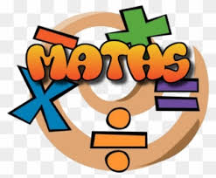
We will be linking our writing to the Victorians and the Industrial Revolution and to our class text: Street Child.  We are learning . . .  - To link our ideas within paragraphs through linking words and phrases  - To use a comma accurately for subordination  - To vary sentence lengths  - To use different tenses accurately within the same text |  |  | We are learning . . .  - Revise and recap retrieval and inference.  - How to answer different question types e.g. multiple choice, ordering.  - Reading with greater fluency, expression and appropriate pace.  Please read with your child every day for at least 10 minutes. |  | We are learning to . . .  - Tell the time to 5 minutes and the minute  - Use A.M and P.M  - Read the 24-hour clock  - Compare, order and round decimals  - Understand pounds and pence  - Order and estimate money  - Add and subtract money
Science |  | RE/PSHE |  | History |  | PE
This half term we will be focusing on Physics.  We will be learning about . . .  Sound  Computing  Sphere Robot – Long jump challenge! |  | This half term we will be learning about . . .  - How our choices can make a difference to others and the environment  - What different religion say about rules and self-discipline |  | Topic: Industrial Revolution  We will be learning about . . .  - Mass production  - Transport links  - Migration  - The effects of the Industrial Revolution and its legacy today |  | In PE this half-term we will be focussing on . . .  Athletics and Handball  PE is on Wednesdays  Your child must wear the appropriate PE kit. This involves….  - Shorts or tracksuits. Close fitting leggings may be worn by girls.  - Trainers or pumps  - A white t-shirt or a house t-shirt
Please ensure your child is on time everyday otherwise they are missing out on their crucial learning time.

